WORKING WITH DATASET

**TEAM MEMBERS**:

SAMUEL AARON K

SRUTHI SRI S C

SUSHMITHAA S

TILAK

PREPARING THE DATASET

|  |  |
| --- | --- |
| Team ID | PNT2022TMID20211 |
| Project Name | Project-Global Sales Data Analytics |

Once the data is loaded, we need to Prepare the data.

1. Prepare Calculations of Year, Month, Day fields and the related Navigation path
2. Create a Few more Calculations – Target Sales, Min Sales, Max Sales, Middle Range Sales.

# Year of Order date:

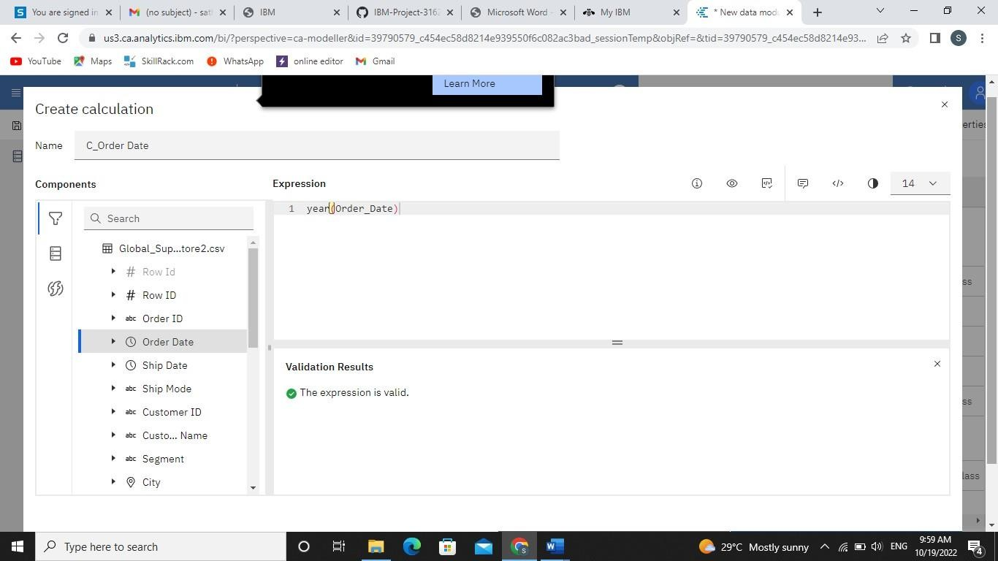

**Month of Order date:**

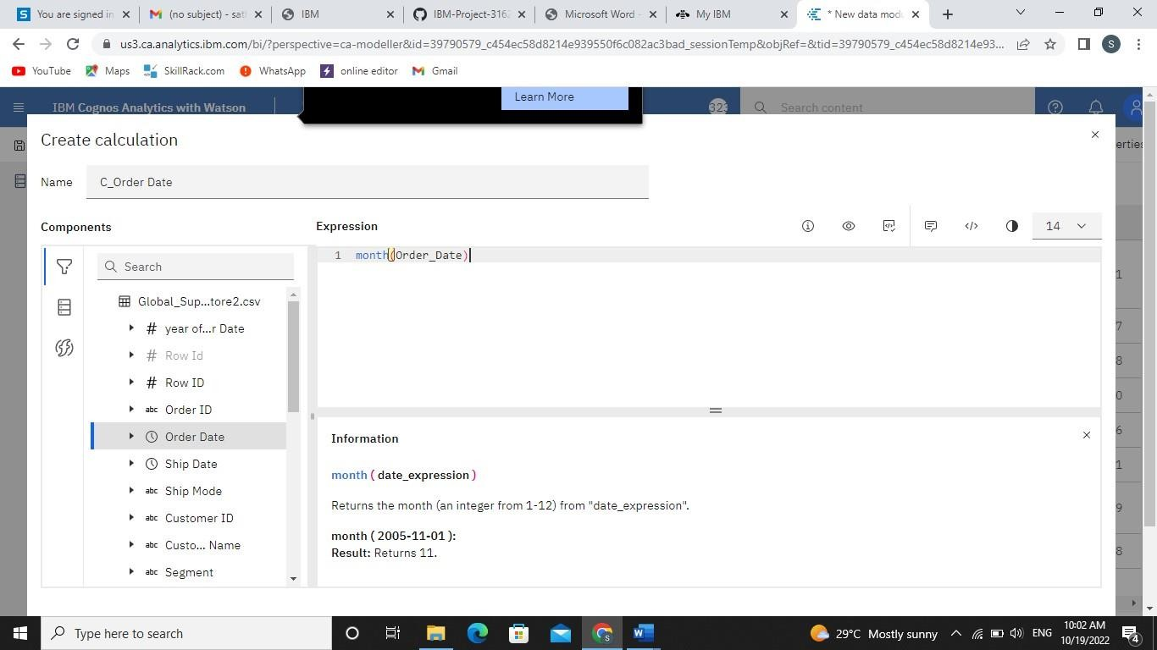

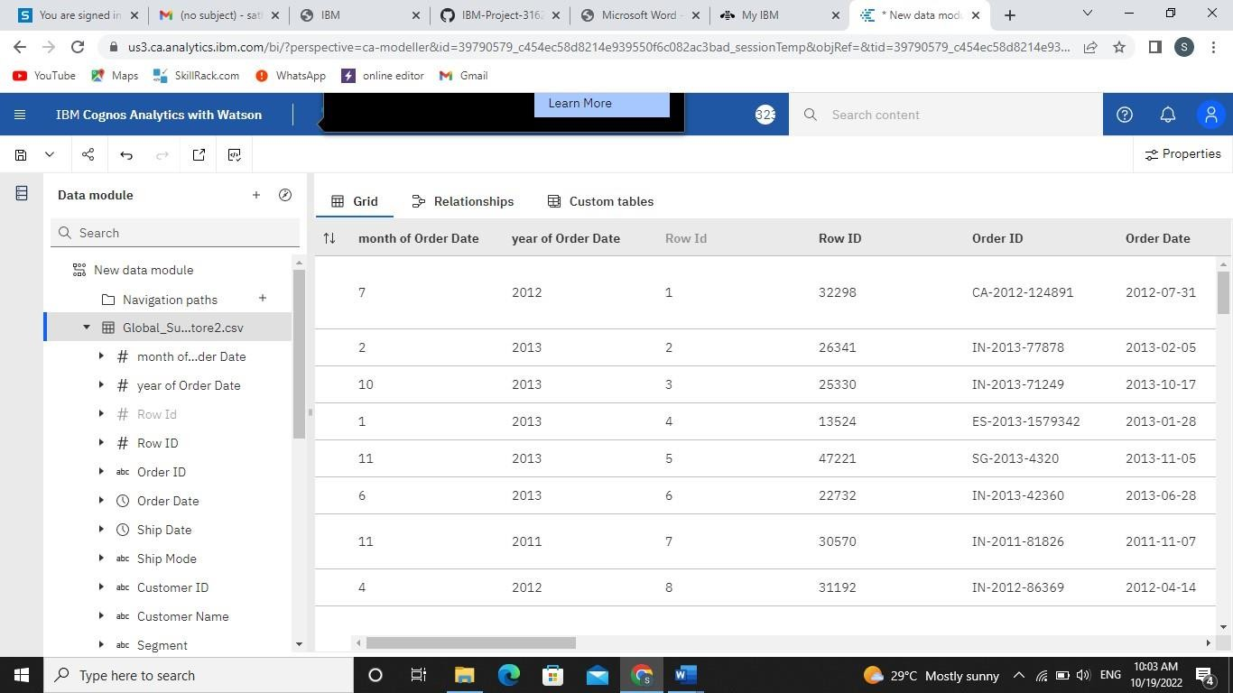

# After Preparing saving the Dataset as:

